CHEM 1021 — Exam 3 Practice Test
Day 5 of 7
Date: ______________________ Score: ________ / 100
Instructions: 25 multiple-choice questions, 4 points each. Choose the single best answer. Give yourself 50 minutes. Use only the reference information below, a periodic table, and a calculator. Fill in the answer sheet on the last page, then grade with the Day 5 Answer Key.
Reference Information
Equations and constants: Molarity = moles solute ÷ liters of solution · M₁V₁ = M₂V₂ · Nₐ = 6.022 × 10²³ · 1 cm³ = 1 mL · 1 L = 1 dm³ · 0.3047 m = 1 ft
The 7 strong acids: HCl, HBr, HI, H₂SO₄, HNO₃, HClO₄, HClO₃. Strong bases: all soluble hydroxide salts.
Common polyatomic ions: ammonium NH₄⁺ · hydronium H₃O⁺ · hydroxide OH⁻ · cyanide CN⁻ · carbonate CO₃²⁻ · phosphate PO₄³⁻ · chlorate ClO₃⁻ · bromate BrO₃⁻ · iodate IO₃⁻ · sulfate SO₄²⁻ · selenate SeO₄²⁻ · nitrate NO₃⁻ · acetate CH₃CO₂⁻
Acid naming: no oxygen → hydro- + root + -ic acid · -ate ion → -ic acid · -ite ion (one fewer O) → -ous acid · one more O than the -ate → per- + root + -ic acid · one fewer O than the -ite → hypo- + root + -ous acid
Activity Series (most → least active; a metal displaces any metal ion listed below it)
Group | Metals | Reacts with
1 | K, Ba, Sr, Ca, Na | Cold water, steam, and acids (produce H₂)
2 | Mg, Al, Mn, Zn, Cr, Fe, Cd | Steam and acids (produce H₂)
3 | Co, Ni, Sn, Pb | Acids only (produce H₂)
— | H₂ | —
4 | Sb, Bi, Cu, Ag, Hg, Pd, Pt | Do not react with water, steam, or acids
Electronegativity (main-group values)
Period | 1 | 2 | 13 | 14 | 15 | 16 | 17
1 | H 2.1
2 | Li 1.0 | Be 1.5 | B 2.0 | C 2.5 | N 3.0 | O 3.5 | F 4.0
3 | Na 0.9 | Mg 1.2 | Al 1.5 | Si 1.8 | P 2.1 | S 2.5 | Cl 3.0
4 | K 0.8 | Ca 1.0 | Ga 1.6 | Ge 1.8 | As 2.0 | Se 2.4 | Br 2.8
5 | Rb 0.8 | Sr 1.0 | In 1.7 | Sn 1.8 | Sb 1.9 | Te 2.1 | I 2.5
Solubility Rules
Ion | Rule | Exceptions
Na⁺, K⁺, NH₄⁺ | Salts with an alkali metal or ammonium ion are soluble | None
NO₃⁻, CH₃CO₂⁻ | All nitrates and acetates are soluble | None
SO₄²⁻ | Most sulfates are soluble | BaSO₄, SrSO₄, PbSO₄, CaSO₄, Hg₂SO₄, Ag₂SO₄
Cl⁻, Br⁻, I⁻ | Most chlorides, bromides, and iodides are soluble | AgX, Hg₂X₂, PbX₂, HgI₂
Ag⁺ | Silver compounds are generally insoluble | AgNO₃ and AgClO₄ are soluble; AgCH₃CO₂ is slightly soluble
O²⁻, OH⁻ | Oxides and hydroxides are insoluble | Alkali metal hydroxides, Ba(OH)₂, Sr(OH)₂; Ca(OH)₂ is somewhat soluble
S²⁻ | Sulfides are insoluble | Compounds with Na⁺, K⁺, NH₄⁺, and alkaline earth cations
CrO₄²⁻ | Most chromates are insoluble | Compounds with Na⁺, K⁺, NH₄⁺, Mg²⁺, Ca²⁺, Al³⁺, Ni²⁺
CO₃²⁻, PO₄³⁻, SO₃²⁻, SiO₃²⁻ | Most carbonates, phosphates, sulfites, and silicates are insoluble | Compounds with Na⁺, K⁺, NH₄⁺

1. Returning Topic: Report the answer to the following calculation with the correct number of significant figures:
(6.02 × 10.00) + 1.3
A. 62
B. 61.5
C. 61.50
D. 61.52
2. Returning Topic: How many cubic millimeters are there in 1.80 cubic centimeters?
A. 1.80 × 10⁻³ mm³
B. 1.80 × 10¹ mm³
C. 1.80 × 10² mm³
D. 1.80 × 10³ mm³
3. Returning Topic: Consider the transition metal zinc (Z = 30). How many d electrons are in the ground-state electron configuration of the Zn²⁺ ion?
A. 8
B. 9
C. 10
D. 12
4. Returning Topic: Which of the following is the correct electron configuration for a neutral nickel (Z = 28) atom?
A. [Ar]4s²4d⁸
B. [Ar]4s¹3d⁹
C. [Ar]3d¹⁰
D. [Ar]4s²3d⁸
5. Copper forms the following compound with oxygen: Cu₂O. What is the name of this compound?
A. copper(II) oxide
B. copper monoxide
C. copper(I) oxide
D. dicopper oxide
6. Which of the following ions would form the strongest bond with a bromide ion?
A. Ca²⁺
B. Ba²⁺
C. K⁺
D. Sr²⁺
7. Consider the compound CO. What is the correct name for this compound?
A. carbon monoxide
B. carbon(II) oxide
C. monocarbon monoxide
D. carbon oxide
8. The element dinoxium reacts with silvane to form a compound with the name dinoxium pentasilvide. Which of the following statements about this compound is correct?
A. The compound is ionic.
B. Silvane is a non-metal element.
C. Dinoxium is a metal.
D. The compound contains two dinoxium atoms.
9. Categorize the following compounds as ionic or covalent.
I: Li₂O II: NH₃ III: NH₄F
A. I, II, and III are all ionic.
B. I is ionic; II and III are covalent.
C. I and III are ionic; II is covalent.
D. I and II are ionic; III is covalent.
10. Which of the following bonds is most polar? (Use the electronegativity table.)
A. C–Br
B. C–O
C. C–Cl
D. C–N
11. What is the electron domain geometry on the atom X in the structure shown?
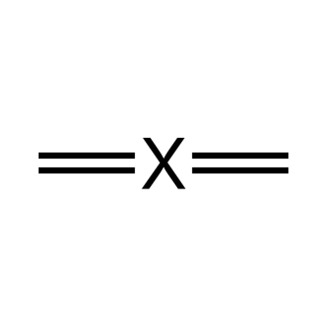
A. Linear
B. Tetrahedral
C. Trigonal planar
D. Bent
12. Predict the molecular shape and the approximate bond angle of sulfur dichloride, SCl₂.
A. Linear, 180°
B. Tetrahedral, 109.5°
C. Bent, < 109.5°
D. Bent, 120°
13. The nitrate ion, NO₃⁻, exhibits resonance. The first resonance structure is shown. Which structure is another valid resonance structure for the nitrate ion?
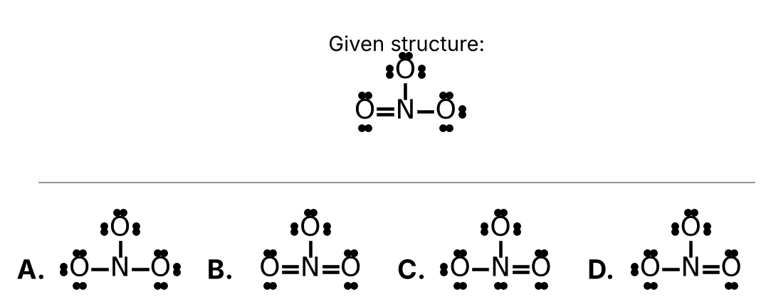
Choose A, B, C, or D from the figure.
14. You dissolve 1.0 g of table sugar in 100 mL of water. Which of the following statements about this solution is correct?
A. Water and sugar are both solutes.
B. There is no solvent because sugar is not ionic.
C. The solvent is sugar and the solute is water.
D. The solvent is water and the solute is sugar.
15. 25.0 mL of a 3.00 M HCl solution is diluted to a final volume of 150.0 mL. What is the concentration of the diluted solution?
A. 0.200 M
B. 0.500 M
C. 2.00 M
D. 18.0 M
16. Use the solubility rules to determine which of the following compounds is not soluble in water.
A. MgCrO₄
B. BaS
C. PbSO₄
D. AgClO₄
17. Torvium (Tv) is a fictional non-metal that forms an acid with the formula HTv. What is the name of this compound?
A. Hydrotorvic acid
B. Pertorvic acid
C. Hydrotorvous acid
D. Torvic acid
18. Draxium (Dx) is a fictional element that forms the polyatomic ion named draxate with the formula DxO₃²⁻. What would be the name of the acid with the chemical formula H₂DxO₄?
A. Draxous acid
B. Hypodraxous acid
C. Draxic acid
D. Perdraxic acid
19. Which of the following, when dissolved in water, will create an electrolyte solution?
A. C₁₂H₂₂O₁₁
B. KOH
C. CH₄
D. CH₃OH
20. Consider the following chemical reaction:
AgNO₃ (aq) + NaCl (aq) → AgCl (s) + NaNO₃ (aq)
Which of the following statements about this reaction is incorrect?
A. NaNO₃ is a product.
B. A solid forms during the reaction.
C. Both reactants are dissolved in water.
D. All of the products are aqueous.
21. Balance the following chemical equation:
Fe (s) + Cl₂ (g) → FeCl₃ (s) (unbalanced)
How many atoms of chlorine are found on the product side when the equation is properly balanced?
A. 2
B. 3
C. 6
D. 9
22. Nitrogen monoxide gas reacts with oxygen gas to produce nitrogen dioxide gas. Write a properly balanced chemical equation for this reaction. How many oxygen molecules are consumed in this reaction?
A. 1
B. 2
C. 3
D. 4
23. Consider the following chemical reaction:
2 SO₂ + O₂ → 2 SO₃
This reaction would be classified as a ____.
A. Single Displacement Reaction
B. Double Displacement Reaction
C. Synthesis (Combination) Reaction
D. Decomposition Reaction
24. Which of the following chemical reactions will not occur?
A. Co (s) + ZnCl₂ (aq) → CoCl₂ (aq) + Zn (s)
B. Cr (s) + Pb(NO₃)₂ (aq) → Cr(NO₃)₂ (aq) + Pb (s)
C. Fe (s) + 2 HCl (aq) → FeCl₂ (aq) + H₂ (g)
D. Mn (s) + NiCl₂ (aq) → MnCl₂ (aq) + Ni (s)
25. Which of the following is not a product of the complete combustion of octane, C₈H₁₈?
A. H₂O
B. C (soot)
C. CO₂
D. Heat

Answer Sheet — Day 5
Circle one letter per question.
# | Answer | # | Answer | # | Answer
1 | A B C D | 10 | A B C D | 19 | A B C D
2 | A B C D | 11 | A B C D | 20 | A B C D
3 | A B C D | 12 | A B C D | 21 | A B C D
4 | A B C D | 13 | A B C D | 22 | A B C D
5 | A B C D | 14 | A B C D | 23 | A B C D
6 | A B C D | 15 | A B C D | 24 | A B C D
7 | A B C D | 16 | A B C D | 25 | A B C D
8 | A B C D | 17 | A B C D
9 | A B C D | 18 | A B C D

